

SOUTH EAST ASIAN INSTITUTE OF TECHNOLOGY, INC.

National Highway, Crossing Rubber, Tupi, South Cotabato

**COLLEGE OF INFORMATION AND COMMUNICATION TECHNOLOGY**

___________________________________________________

**LEARNING MODULE**

**FOR**

**IT 123: WEB DEVELOPMENT 1**

**_____________________________________________________**

***WEEK 13***

**COURSE OUTLINE**

**COURSE CODE**  : IT 123

**TITLE**  : Web Development 1

**TARGET POPULATION** : All BS Information Technology Students

**INSTRUCTOR** : MS. CAROL KATE M. ESTACIO

**Overview:**

HTML stands for Hypertext Markup Language, and it is the most widely used language to write Web Pages.

• Hypertext refers to the way in which Web pages (HTML documents) are linked together. Thus, the link available on a webpage is called Hypertext.

• As its name suggests, HTML is a Markup Language which means you use HTML to simply "mark-up" a text document with tags that tell a Web browser how to structure it to display.

Originally, HTML was developed with the intent of defining the structure of documents like headings, paragraphs, lists, and so forth to facilitate the sharing of scientific information between researchers.

Now, HTML is being widely used to format web pages with the help of different tags available in HTML language.

**Content:**

**CSS**

* + **CSS Borders**
  + **CSS Margins**
  + **CSS Padding**
  + **CSS Box Model**

**Objectives:**

General Objective

* + To know how to create borders on your website.
  + Set margins and padding
  + To know the different parts of the box

**Instruction to the Learner**

Each chapter in this module contains a major lesson involving the basics of Web page coding and HTML editing tool. The units are characterized by continuity, and are arranged in such a manner that the present unit is related to the next unit. For this reason, you are advised to read this module. After each unit, there are exercises to be given. Submission of task given will be every Monday during your scheduled class hour.

**CSS Border**

CSS border properties allow you to specify the style, width, and color of an element’s border.

Border Style

The border-style property specifies what kind of border to display. The following values are allowed:

* Dotted – defines a dotted border
* Dashed – defines a dashed border
* Solid – defines a solid border
* Double – defines a double border
* Groove – defines a 3D grooved border. The effect depends on the border-color value
* Ridge – defines a 3D ridge border. The effect depends on the border-color value
* Inset – defines a 3D inset border. The effect depends on the border-color value
* Outset – defines a 3D outset border. The effect depends on the border-color value
* None – defines no border
* Hidden – defines a hidden border

The border-style property can have from one to four values (for the top border, right border, bottom border, and the left border).

**Example**

p.dotted {border-style: dotted;}  
p.dashed {border-style: dashed;}  
p.solid {border-style: solid;}  
p.double {border-style: double;}  
p.groove {border-style: groove;}  
p.ridge {border-style: ridge;}  
p.inset {border-style: inset;}  
p.outset {border-style: outset;}  
p.none {border-style: none;}  
p.hidden {border-style: hidden;}  
p.mix {border-style: dotted dashed solid double;}

**Output**

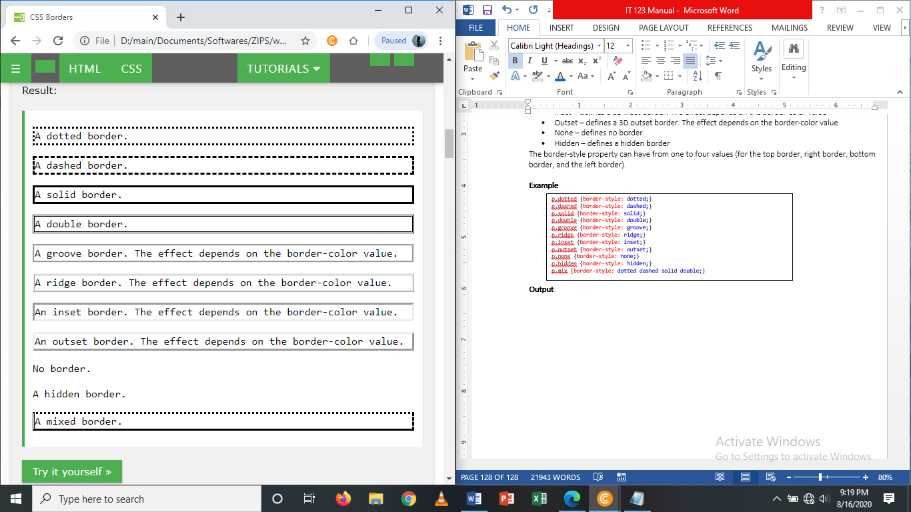

**Border Width**

The border-width property specifies the width of the four borders. The width can be set as a specific size (in px, pt, cm, em, etc) or by using one of the three pre-defined values: thin, medium, or thick. The border-width property can have from one to four values (for the top border, right border, bottom border, and the left border).

p.one {  
    border-style: solid;  
    border-width: 5px;  
}  
  
p.two {  
    border-style: solid;  
    border-width: medium;  
}  
  
p.three {  
    border-style: solid;  
    border-width: 2px 10px 4px 20px;  
}

**Example** **Output**

<!DOCTYPE html>

<html>

<head>

<style>

p.one {

border-style: solid;

border-width: 5px;

}

p.two {

border-style: solid;

border-width: medium;

}

p.three {

border-style: dotted;

border-width: 2px;

}

p.four {

border-style: dotted;

border-width: thick;

}

p.five {

border-style: double;

border-width: 15px;

}

p.six {

border-style: double;

border-width: thick;

}

p.seven {

border-style: solid;

border-width: 2px 10px 4px 20px;

}

</style>

</head>

<body>

<h2>The border-width Property</h2>

<p>This property specifies the width of the four borders:</p>

<p class="one">Some text.</p>

<p class="two">Some text.</p>

<p class="three">Some text.</p>

<p class="four">Some text.</p>

<p class="five">Some text.</p>

<p class="six">Some text.</p>

<p class="seven">Some text.</p>

<p><b>Note:</b> The "border-width" property does not work if it is used alone.

Always specify the "border-style" property to set the borders first.</p>

</body>

</html>

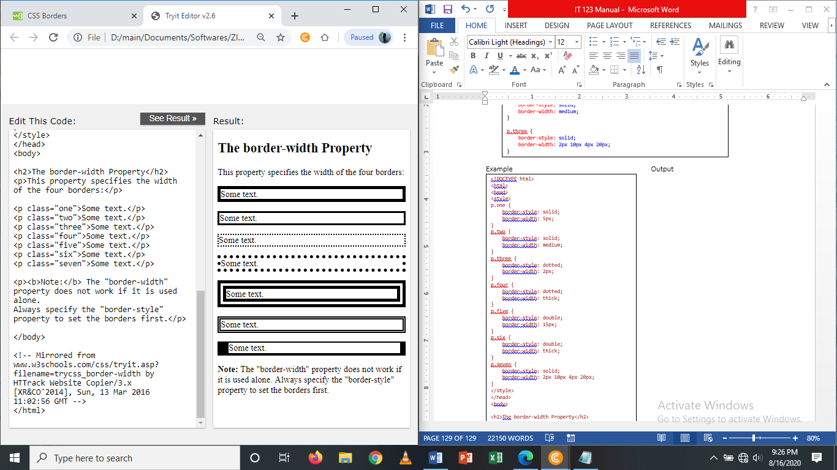

Border Color

The border-color property is used to set the color of the four borders. The color can be set by:

* Name – specify a color name, like “red”
* HEX – specify a hex value, like “#ff0000”
* RGB – specify a RGB value, like “rgb(255,0,0)”
* Transparent

The border-color property can have from one to four values (for the top border, right border, bottom border, and the left border). If border-color is not set, it inherits the color of the element.

**Example Output**

<!DOCTYPE html>

<html>

<head>

<style>

p.one {

border-style: solid;

border-color: red;

}

p.two {

border-style: solid;

border-color: green;

}

p.three {

border-style: solid;

border-color: red green blue yellow;

}

</style>

</head>

<body>

<h2>The border-color Property</h2>

<p>This property specifies the color of the four borders:</p>

<p class="one">A solid red border</p>

<p class="two">A solid green border</p>

<p class="three">A solid multicolor border</p>

<p><b>Note:</b> The "border-color" property does not work if it is used alone. Use the "border-style" property to set the borders first.</p>

</body>

</html>

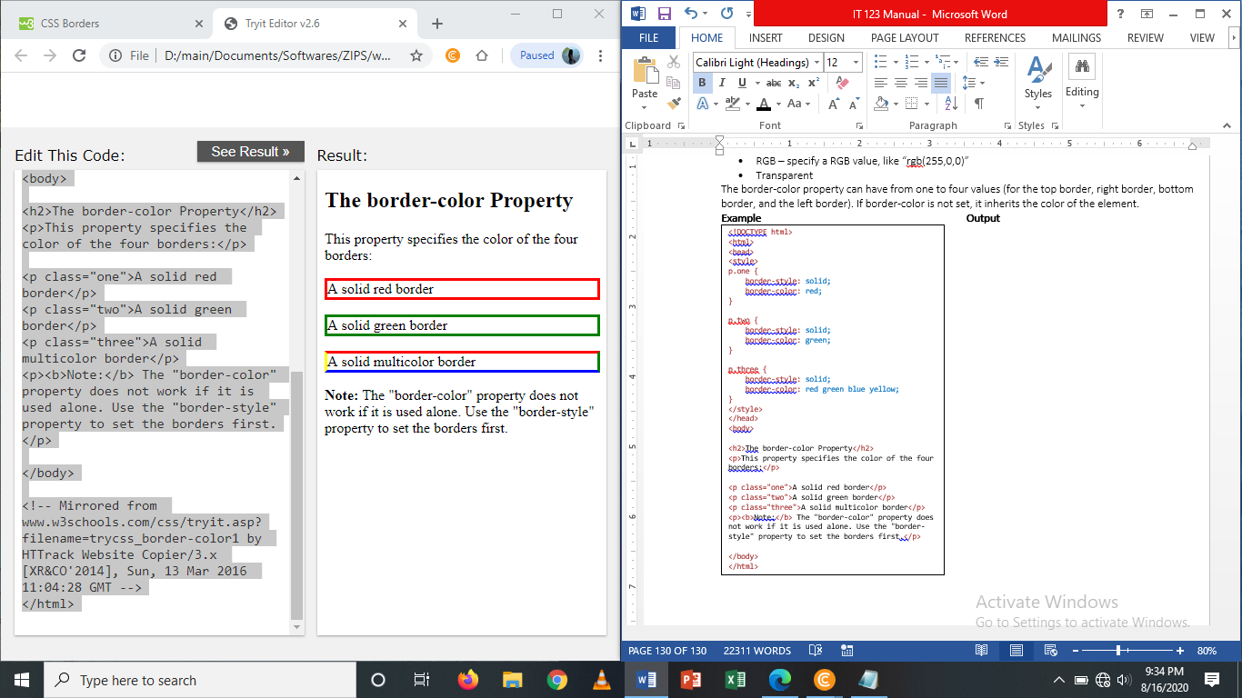

**Border – Individual Sides**

From the examples above you have seen that it is possible to specify a different border for each side. In CSS, there is also properties for specifying each of the borders (top, right, bottom, and left):

p {  
    border-style: dotted solid;  
}

p {  
    border-top-style: dotted;  
    border-right-style: solid;  
    border-bottom-style: dotted;  
    border-left-style: solid;  
}

The above gives the same result as this:

**Example Output**

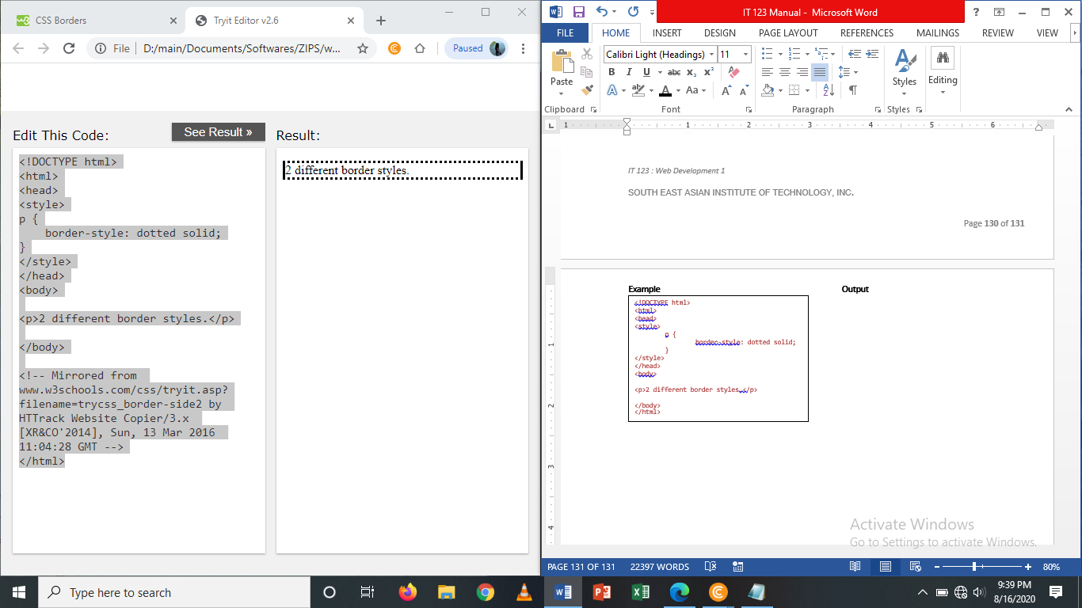

<!DOCTYPE html>

<html>

<head>

<style>

p {

border-style: dotted solid;

}

</style>

</head>

<body>

<p>2 different border styles.</p>

</body>

</html>

**All CSS Border Properties**

|  |  |
| --- | --- |
| Property | Description |
| Border | Sets all the border properties in one declaration |
| Border-bottom | Sets all the bottom border properties in one declaration |
| Border-bottom-color | Sets the color of the bottom border |
| Border-bottom-style | Sets the style of the bottom border |
| Border-bottom-width | Sets the width of the bottom border |
| Border-color | Sets the color of the four borders |
| Border-left | Sets all the left border properties in one declaration |
| Border-left-color | Sets the color of the left border |
| Border-left-style | Sets the style of the left border |
| Border-left-width | Sets the width of the left border |
| Border-right | Sets all the right border properties in one declaration |
| Border-right-color | Sets the color of the right border |
| Border-right-style | Sets the style of the right border |
| Border-right-width | Sets the width of the right border |
| Border-style | Sets the style of the four borders |
| Border-top | Sets all the top border properties in one declaration |
| Border-top-color | Sets the color of the top border |
| Border-top-style | Sets the style of the top border |
| Border-top-width | Sets the width of the top border |
| Border-width | Sets the width of the four borders |

**CSS Margins**

The CSS Margin property set the size of the white space outside the border. With CSS, you have full control over the margins. There are CSS properties for setting the margin for each side of an element (top, right, bottom, and left). The margins are completely transparent - and cannot have a background color.

Margin – Individual Sides

CSS has properties for specifying the margin for each side of an element:

* Margin-top
* Margin-right
* Margin-bottom
* Margin-left

All the margin properties can have the following values:

* Auto – the browser calculates the margin
* Length – specifies a margin in px, pt, cm, etc.
* % - specifies a margin in % of the width of the containing element
* Inherit – specifies that the margin should be inherited from the parent element

**Example #1**

<!DOCTYPE html>

<html>

<head>

<style>

p {

background-color: yellow;

}

p.ex {

border:1px solid red;

margin-top: 100px;

margin-bottom: 100px;

margin-right: 150px;

margin-left: 80px;

}

</style>

</head>

<body>

<h2>Using Individual margin Properties:</h2>

<p>This is a paragraph with no specified margins.</p>

<p class="ex">This paragraph has a top and bottom margin of 100px, a left margin of 80px, and a right margin of 150px.</p>

</body>

</html>

**Output**

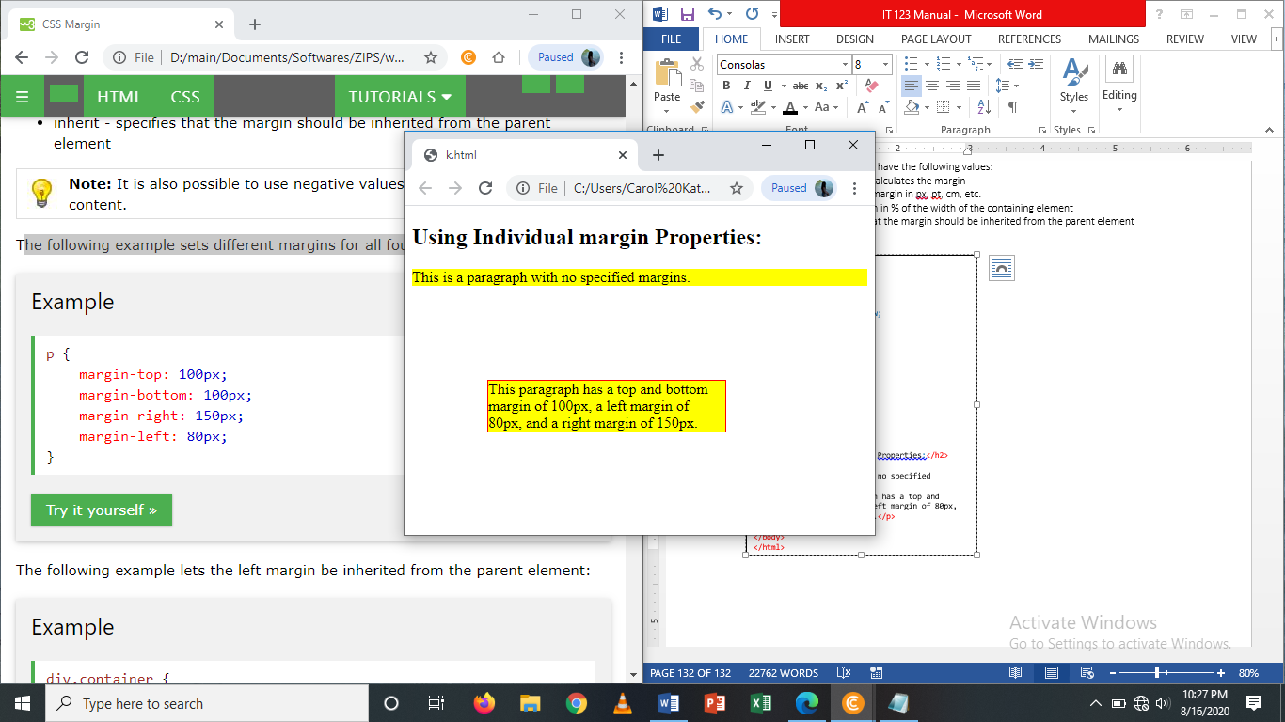

Example #2

<!DOCTYPE html>

<html>

<head>

<style>

div.container {

border: 1px solid red;

margin-left: 100px;

}

p.one {

margin-left: inherit;

}

</style>

</head>

<body>

<h2>Use of the inherit Value</h2>

<p>Let the left margin be inherited from the parent element:</p>

<div class="container">

<p class="one">This is a paragraph with an inherited left margin (from the div element).</p>

</div>

</body>

</html>

**Output**

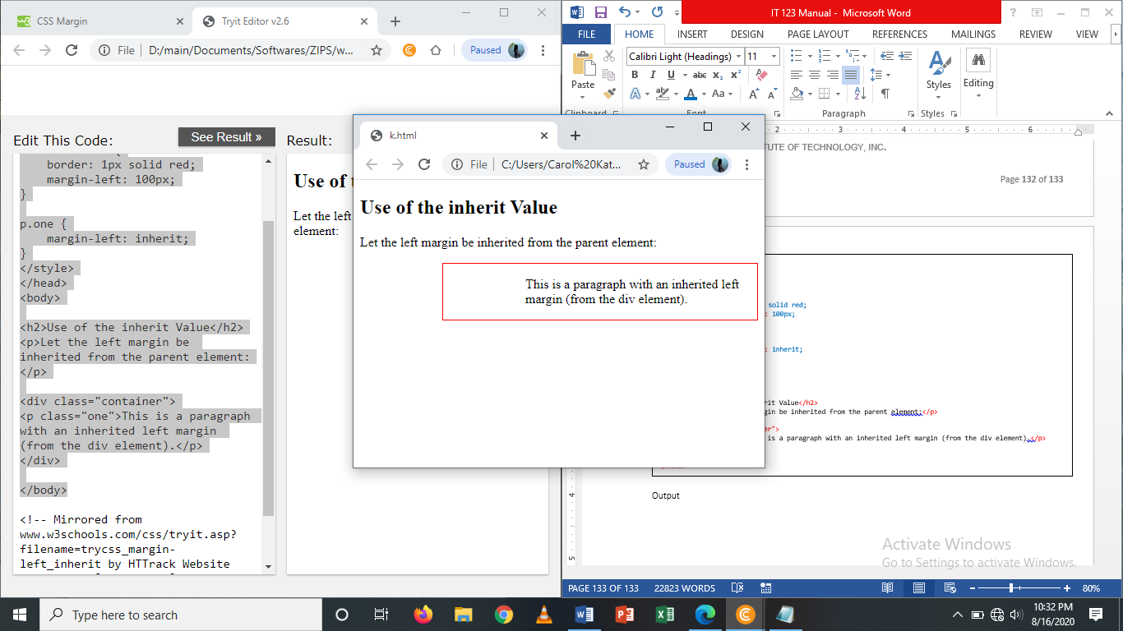

**Margin-Shorthand Property**

To shorten the code, it is possible to specify all the margin properties in one property. The margin property is a shorthand property for the following individual margin properties:

* Margin-top
* Margin-right
* Margin-bottom
* Margin-left

p {  
    margin: 100px 150px 100px 80px;  
}

Use of the auto value

You can set the margin property to auto to horizontally center the element within its container. The element will then take up the specified width, and the remaining space will be split equally between the left and right margins:

div {  
    width: 300px;  
    margin: auto;  
    border: 1px solid red;  
}

**CSS Padding**

The CSS padding properties defines the white space between the element content and the element border. The padding clears an area around the content (inside the border) of an element. With CSS, you have full control over the padding. There are CSS properties for setting the padding for each side of an element (top, right, bottom, and left).

Padding – individual Sides

CSS has properties for specifying the padding for each side of an element:

* Padding-top
* Padding-right
* Padding-bottom
* Padding-left

All the padding properties can have the following values:

* Length – specifies a padding in px, pt, cm, etc.
* % - specifies a padding in % of the width of the containing element
* Inherit – specifies that the padding should be inherited from the parent element

**Example:** (The following example sets different padding for all four sides of a <p> element)

<!DOCTYPE html>

<html>

<head>

<style>

p.one {

border: 1px solid red;

background-color: yellow;

padding-top: 50px;

padding-right: 30px;

padding-bottom: 50px;

padding-left: 80px;

}

</style>

</head>

<body>

<h2>Using Individual padding Properties:</h2>

<p>This is a paragraph with no specified padding.</p>

<p class="one">This paragraph has a top and bottom padding of 50px, a left padding of 80px, and a right padding of 30px.</p>

</body>

</html>

**Output**

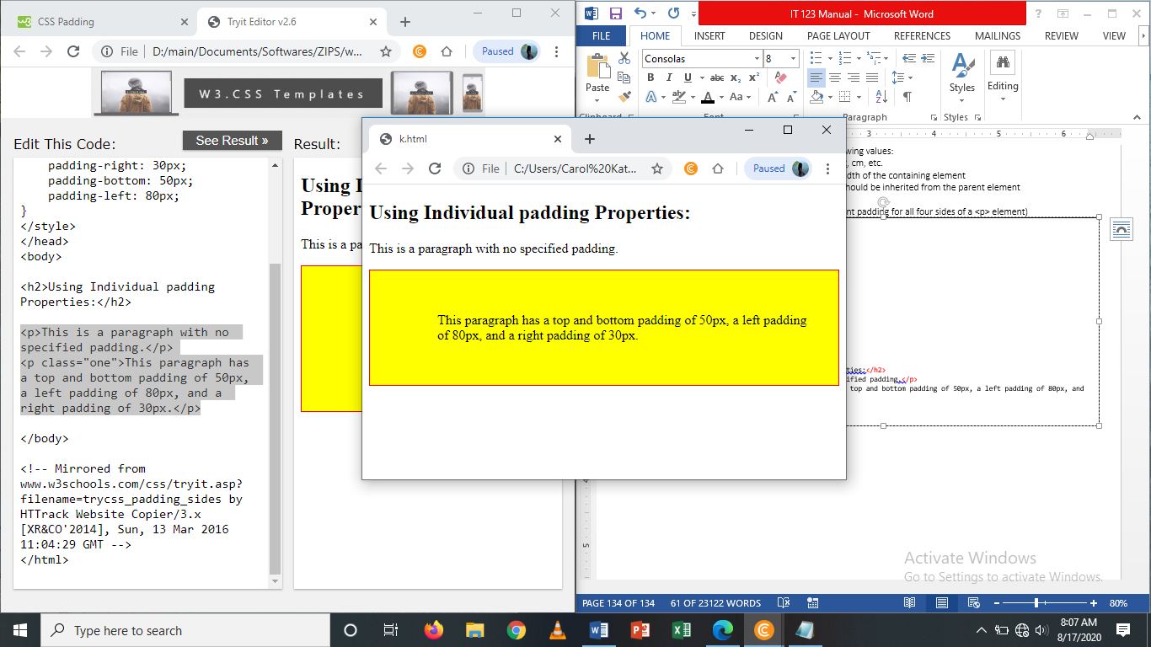

**Padding – Shorthand Property**

To shorten the code, it is possible to specify all the padding properties in one property. The *padding* property is a shorthand property for the following individual padding properties:

* Padding-top
* Padding-right
* Padding-bottom
* Padding-left

**All CSS Padding Properties**

|  |  |
| --- | --- |
| Property | Description |
| padding | A shorthand property for setting all the padding properties in one declaration |
| padding-bottom | Sets the bottom padding of an element |
| padding-left | Sets the left padding of an element |
| padding-right | Sets the right padding of an element |
| padding-top | Sets the top padding of an element |

**CSS Box Model**

All HTML elements can be considered as boxes. In CSS, the term "box model" is used when talking about design and layout. The CSS box model is essentially a box that wraps around every HTML element. It consists of: margins, borders, padding, and the actual content. The image below illustrates the box model:

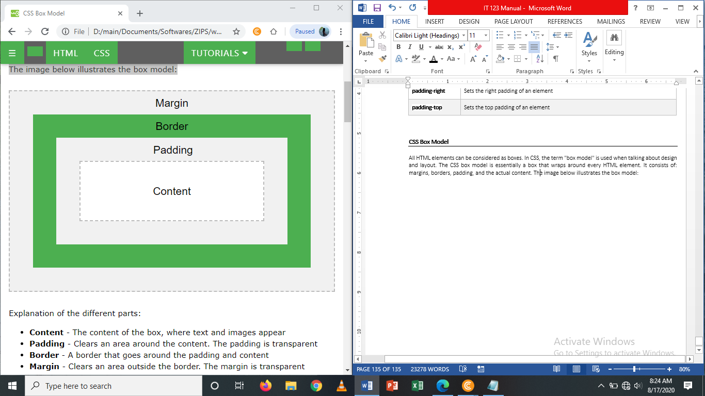

**Explanation of the different parts:**

* **Content** – the content of the box, where text and images appear
* **Padding** – clears an area around the content. The padding is transparent
* **Border** – a border that goes around the padding and content
* **Margin** – clears an area outside the border. The margin is transparent

The box model allows us to add a border around elements, and to define space between elements.

**Example**

<!DOCTYPE html>

<html>

<head>

<style>

div {

background-color: lightgrey;

width: 300px;

padding: 25px;

border: 25px solid navy;

margin: 25px;

}

</style>

</head>

<body>

<h2>Demonstrating the Box Model</h2>

<p>The CSS box model is essentially a box that wraps around every HTML element. It consists of: margins, borders, padding, and the actual content.</p>

<div>Lorem ipsum dolor sit amet, consectetur adipiscing elit, sed do eiusmod tempor incididunt ut labore et dolore magna aliqua. Ut enim ad minim veniam, quis nostrud exercitation ullamco laboris nisi ut aliquip ex ea commodo consequat. Duis aute irure dolor in reprehenderit in voluptate velit esse cillum dolore eu fugiat nulla pariatur. Excepteur sint occaecat cupidatat non proident, sunt in culpa qui officia deserunt mollit anim id est laborum.</div>

</body>

</html>

**Output**

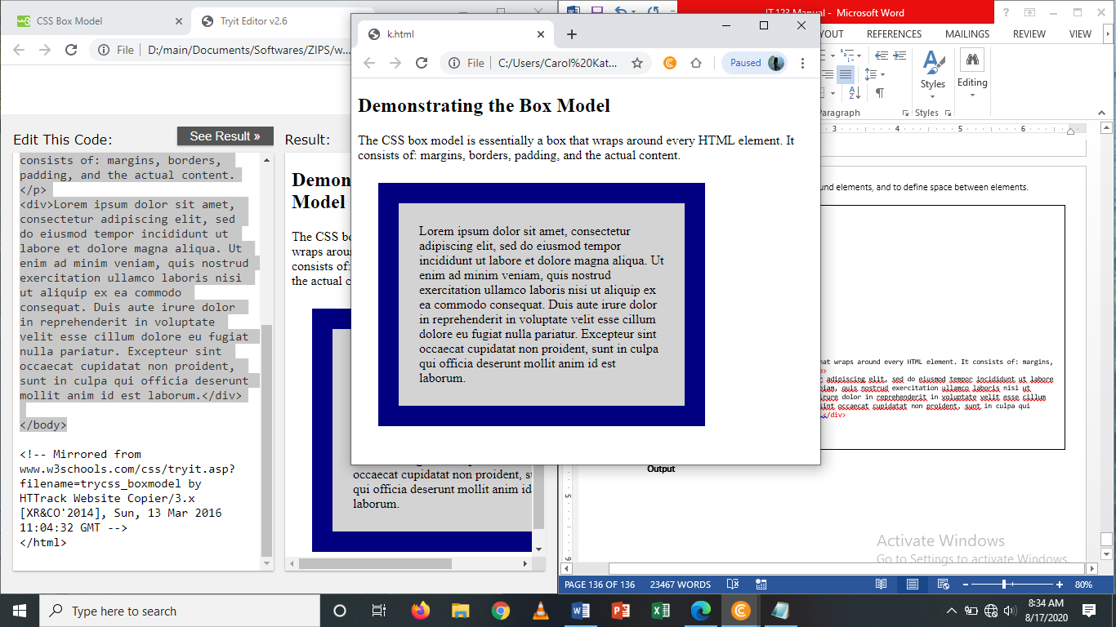

**Review Questions**

1. Which property of a hyperlink signifies an element that currently has the user’s mouse pointer hovering over it?
2. Discuss what is the Box Model in CSS? Which properties are a part of it?
3. How do margin, border and padding fit together in the box model?
4. Briefly discuss what property specifies the distance between the borders of adjacent cells.
5. What are the parts of box model and discuss each parts?
6. How will you handle a multiple borders?
7. Is it possible to add some icons in designing a menu? How?
8. Describe what a “reset” CSS file does and how it’s useful.
9. How does reset CSS differ with the normalize.css?
10. What are the various techniques for clearing floats?

**Test Yourself**

1. Set the border of the div to “25px solid navy”. On the output below.

***Output to be used:***

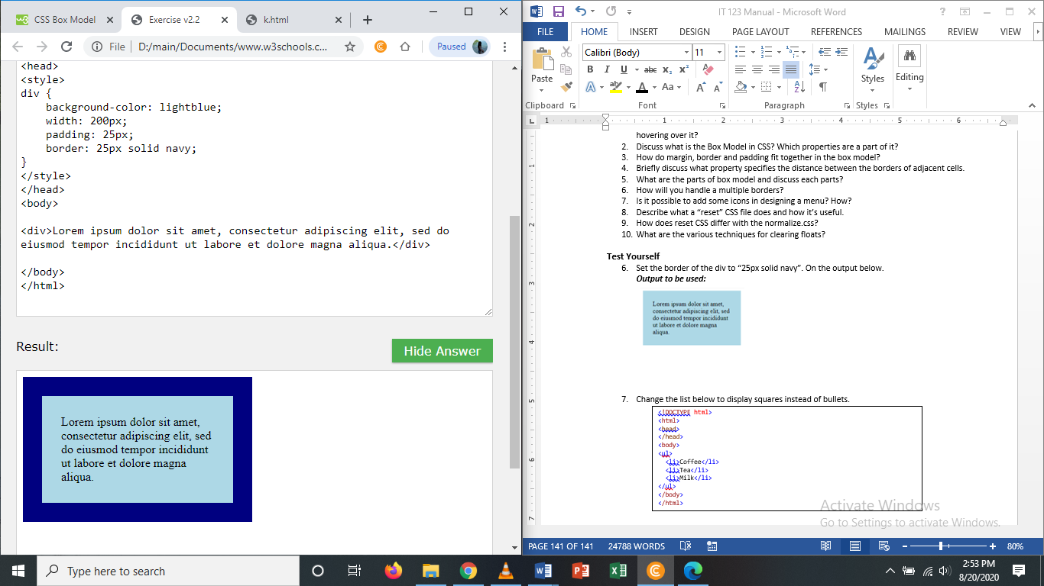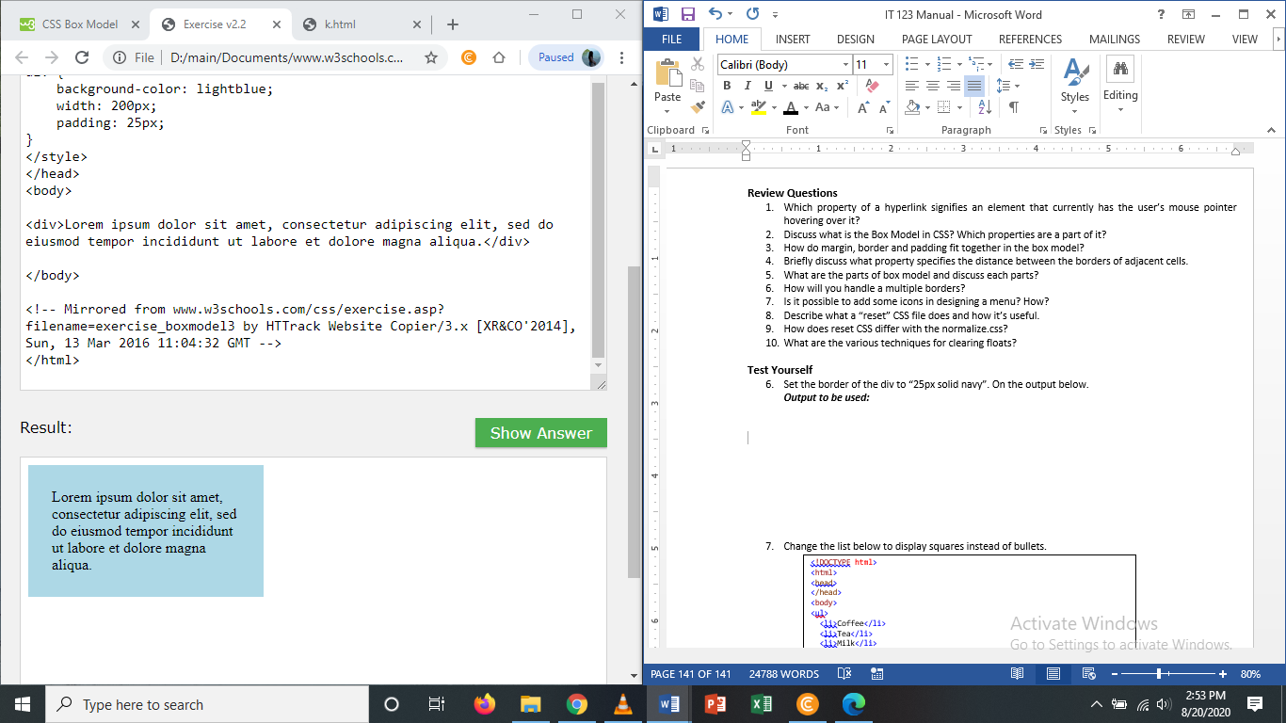

1. Set all paddings for <p> to “50px” with background-color “lightblue”. Content [This is Heading:This is a paragraph.]

***Sample output:***

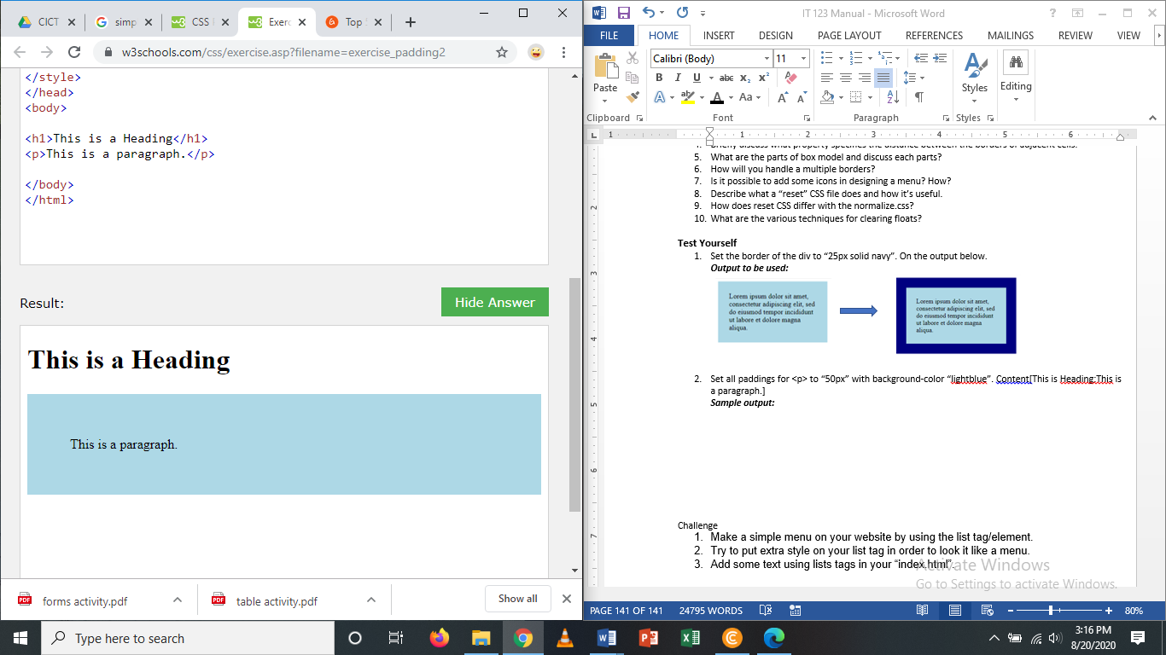

Challenge

1. On your html files add some border.
2. Add some margin and padding.
3. Make sure that you are using it properly and don’t over use border attribute.